# **Major factors influencing the cost of child care in the United States**

# Introduction

Child care centers are structured facilities that provide care and educational services for young children, typically from infancy to age five. They play a crucial role in early childhood development by offering a safe and nurturing environment where children can learn, socialize, and develop essential skills. They enable parents to pursue employment or education by providing reliable care, contributing to family stability and economic growth. The objective of this study is to identify and analyze the key factors influencing the affordability of child care, including economic, demographic, and policy-related variables.

# Dataset

# The dataset selected for this analysis, known as the “National Database of Childcare Prices,” comprises 227 features. My goal is to refine this dataset to a more focused subset of 70 relevant features for a thorough examination. After completing the necessary data preparation, I commenced an exploration of the significant factors that impact the median prices of child care centers. Key variables under investigation include median earnings, female median earnings, the number of households in the county, the proportion of single-mother households, dual-income families, and the overall poverty rate.

# Summary of Analysis

##### Findings

Upon studying the major factors influencing the Child Care Cost in the United States, below are summary of findings

##### Affordability

* As Median Household Income increases, Affordability scores also increase – states with higher incomes are typically less affordable.
* States with higher or lower unemployment rates can both have varying levels of affordability – job availability alone does not explain how affordable a state is to live in.
* Median prices and earnings both rose significantly, but affordability slightly improved overall – while costs increased, household earnings also grew enough to maintain and enhance affordability levels over time.
* Affordability disparities by race are evident – minority groups generally face higher living costs relative to their economic capacity.

##### Economic Factors

* Positive correlation between median child care prices for children ages 6-11 and median household income is evident, indicating that higher incomes are associated with increased child care costs.
* *M*ale and female median earnings have gradually increased over time, the annual median price of Child Care services remains significantly lower than both, highlighting a disparity between earnings growth and service costs.
* A negative relationship exists between female unemployment rates (ages 20-64) and median prices, suggesting that higher unemployment is associated with lower median child care costs.
* Median child care prices for children ages 12-17 vary significantly across different employment rate bins, with higher prices associated with lower employment rates.

##### Social Factors

* The correlations between ethnicity and median child care prices reveals varying relationships among different ethnic groups, highlighting the complexities of child care affordability across demographics.
* As poverty rates rise, the median prices for child care centers tend to decrease, indicating that regions with higher poverty levels often have lower child care costs.
* Significant disparities in median child care prices across various demographics is observed. The analysis highlights the correlation between economic status and the cost of child care, showing that families from lower-income backgrounds face greater financial burdens.
* The Analysis reveals significant variations among states, suggesting that child care affordability plays a crucial role in influencing women’s ability to fully participate in the labor market.

##### Assumptions

* The prices in the dataset are considered accurate and reflect the actual charges from childcare providers at the time of data collection.
* The data collection methodology has remained consistent over the years, allowing for valid comparisons over time.
* The use of median prices assumes that medians better represent typical costs than means, especially in datasets with skewed distributions.
* Childcare providers report their prices and other relevant data truthfully and consistently.

# Items that still need clarification

* The median price of childcare services is unavailable for Indiana and New Mexico. It is unclear whether a more recent dataset that includes these states is available.
* Additional details about childcare providers, such as their size, quality ratings, and staff qualifications, which influence pricing is not available.
* Median Income and Median Earning information for specific population group such as Household with single mothers would have added more dimension for focused analysis.

# Direction of Story

* Provide an overview of the importance of child care in supporting families and the economy, emphasizing the challenges posed by rising costs.
* Offer the context about the current state of child care affordability, including statistics on costs, demographics, economic factors.
* Analyze major factors influencing the cost of child care such as Affordability, Economic, and social factors.
* Report the findings from the data analysis, highlighting significant trends and relationships between these factors and child care costs.
* Discuss the effects of these findings for families, policymakers, and child care providers, emphasizing the need for targeted interventions to improve affordability.
* Conclude with a summary of insights gained, call to action, potential recommendations for addressing the issues identified, aiming to foster a more equitable child care system which will enable policymakers, stakeholders, and communities to collaborate towards equitable solutions.

# Call to Action

The analysis should produce meaningful insight that will

1. Assist policymakers in implementing reforms to improve childcare affordability, including increasing subsidy and increasing access to high-quality childcare programs.
2. Increase awareness about the role of affordable childcare in child development and its broader impact on families' social and financial well-being.
3. Equip families with the knowledge to advocate for their needs and actively participate in discussions about childcare policies, ensuring their voices are included in decision-making.
4. Encourage employers to adopt flexible work policies that help parents, such as remote work opportunities and flexible hours, to help them balance work and childcare responsibilities.
5. Assist Child Care Centers with various aspects such as knowledge, infrastructure, resources that could help them reduce the cost while still retaining or improving services.

# Medium

# Tableau Dashboards

# Area of Focus

**Affordability** in childcare is heavily influenced by median earnings, as families often allocate a significant portion of their income to cover these expenses. When childcare costs exceed a reasonable percentage of a family's income (typically 10%), it can strain their financial stability and limit access to quality care. Affordability score has been calculated for each county for each year and will be used for analysis.

**Affordability Score = Median Price of Child Care Cost / Median Household Income**

**Geographic location** significantly impacts childcare affordability. Urban areas typically face higher living costs, driving up childcare prices. Additionally, the availability of state and federal subsidies varies by region, affecting overall affordability. Cultural perspectives on childcare also differ, influencing both demand and pricing across locations.

# Audience

Primary audience for this medium includes

1. **Policy Makers:** Use data-driven insights to create or modify policies enhancing childcare affordability and accessibility, ensuring funds are allocated effectively.
2. **Government Officials:** Design evidence-based programs to support families and assess the impact of childcare costs on community well-being and economic stability.
3. **Stakeholders from Child Care Organizations:** Stay informed about affordability trends to adjust pricing and services, advocate for beneficial changes, and balance affordability with quality care.

# Visualization

## Affordability for Hight Cost States

The Analysis illustrates the average childcare affordability scores for high-cost states from 2016 to 2023. It highlights a general downward trend, indicating worsening affordability over the years for states like California and Hawaii. Massachusetts and New York also show declining scores, while Puerto Rico remains consistently low. This trend raises concerns about the increasing difficulty of achieving affordability in these high-cost regions.

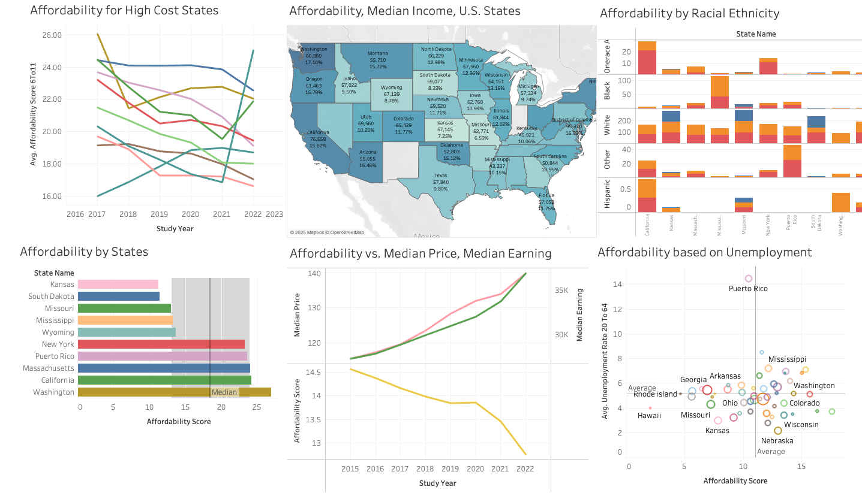

## Affordability for Hight Cost States

The Analysis illustrates the average childcare affordability scores for high-cost states from 2016 to 2023. It highlights a general downward trend, indicating worsening affordability over the years for states like California and Hawaii. Massachusetts and New York also show declining scores, while Puerto Rico remains consistently low. This trend raises concerns about the increasing difficulty of achieving affordability in these high-cost regions.

## Affordability Vs. Median Income – U.S. States

The map depicts child care affordability as a percentage of median income across U.S. states, with varying shades of blue indicating affordability levels. Massachusetts and Vermont show the highest affordability percentages, while California and New York have lower scores. There are notable regional disparities, particularly in southern states where more income is spent on child care, highlighting challenges families face in accessing affordable child care services nationwide.

## Affordability by Racial Ethnicity

The analysis demonstrates child care affordability levels segmented by racial ethnicity across various states. Each bar represents different affordability categories such as Affordable, Expensive, and Manageable, differentiated by color. It reveals significant disparities, with states showing varied experiences in affordability based on racial and ethnic demographics. Notably, states like California and New York display a higher prevalence of "Expensive" categories across multiple ethnic groups, indicating a broader challenge in achieving child care affordability.

## Affordability by States

The study examines child care affordability scores across the U.S., revealing notable disparities. Kansas and South Dakota are identified as the most affordable states, while California and Massachusetts show higher affordability scores, indicating financial strain. New York and Washington also face challenges in accessing affordable child care. The median line highlights that many states surpass this benchmark showcasing widespread issue of affordability facing families.

## Affordability Vs. Median Price, Median Earning

The analysis reveals the relationship between child care affordability scores and median costs over several years. While the average median earnings have been gradually increasing, the median price for child care has risen significantly, indicating a growing financial burden on families. Concurrently, the affordability score has declined, reflecting the increasing gap between earnings and child care costs. This trend highlights the escalating challenges families face in securing affordable child care despite rising incomes.

## Affordability based on Unemployment

## The research conveys the relationship between average unemployment rates and child care affordability scores across various states. States with higher unemployment rates, such as Mississippi and Louisiana, tend to have lower affordability scores, indicating a greater financial strain on families. Conversely, states like Hawaii showcase a higher affordability score despite varying unemployment rates. This visualization highlights how economic conditions, specifically unemployment, can significantly impact the affordability of child care services.

# PowerPoint Presentation

# Area of Focus

**Median income** – Serves as a benchmark for determining what families can reasonably afford to spend on child care. Higher median incomes typically indicate greater purchasing power, allowing families to allocate more funds toward child care expenses.

**Labor force participation** – Child care costs can significantly affect parents' decisions to return to work. If employment rates are low and child care is expensive, parents may opt to stay home, impacting family income and economic productivity.

**Employment Rate** – A Employment rates can be indicators of economic health. When employment is high, there is often more investment in child care services, leading to better availability and potentially lower costs due to increased competition. Consequently, fostering job growth not only benefits the economy but also enhances access to quality child care, supporting parents in their ability to work and contribute to the economy.

# Audience

Primary audience for this medium includes

1. **Policy Makers:** Helps policymakers understanding economic indicators like median income, employment rates, etc., and make informed decisions about child care funding and subsidies. Insights about child care cost’s impact on workforce participation and economic stability will help shaping programs like tax credits and expanded subsidies to better support working families.
2. **Parents/Guardians:** Helps parents understand economic indicators so that they can budget and plan effectively for child care costs. Informed parents are better equipped to advocate for policies that improve child care affordability. Recognizing the link between employment and child care costs enables families make career and work-life balance decisions that support long-term well-being.

# Presentation Slides

# Introduction



# Challenges



# Objective of the Study & Methodology



# Can Families Afford Child Care on a Median income?



# Are Earnings sufficient to cover Child Care Expenses?



# Is there a penalty of Employment for Child Care Expense?



# Call to Action



# Recommendation



# Web Blog

# Area of Focus

Social factors also play a critical role in childcare affordability, with variations observed across different racial and ethnic groups. Additionally, population density and the number of households in an area can impact demand for childcare services, further affecting pricing dynamics. Understanding the social factors influencing child care costs can enhance public discourse around workforce participation, support diverse communities and ensure equitable access to affordable child care options, and support the overall well-being of families and children within various communities.

# Audience

1. Parents/Guardians: Understanding social factors empowers parents to push for policies that improve child care affordability. By grasping the impact of their financial decisions, they can effectively engage with policymakers to drive meaningful change.
2. General Public (Including Policymakers, Government Officials, etc.): The public gains insight into how child care affordability influences community dynamics, economic stability, and workforce participation. This awareness encourages advocacy for family-supportive policies and fosters a culture that values affordable child care, promoting collective action to address these challenges.

# Web Blog Location

# Social Factors Influencing Cost of Child Care

**Racial Disparities: Unequal Burdens in Childcare Affordability**

The correlations between ethnicity and median child care prices is intriguing. The data reveals varying relationships among different ethnic groups, highlighting the complexities of child care affordability across demographics.

Key findings indicate that certain ethnicities, such as those represented by "Asian" and "American Indian," show a significant negative correlation with median child care prices, suggesting that these groups may face higher costs. In contrast, other groups like "Hispanic" and "Other Race" exhibit less pronounced relationships with pricing.

Analysis serves as a critical tool for understanding how ethnic diversity influences child care expenses, prompting further investigation into the socioeconomic factors at play. As communities strive for equitable access to affordable child care, these insights could inform policymakers and stakeholders working to bridge the gap for underrepresented families.

[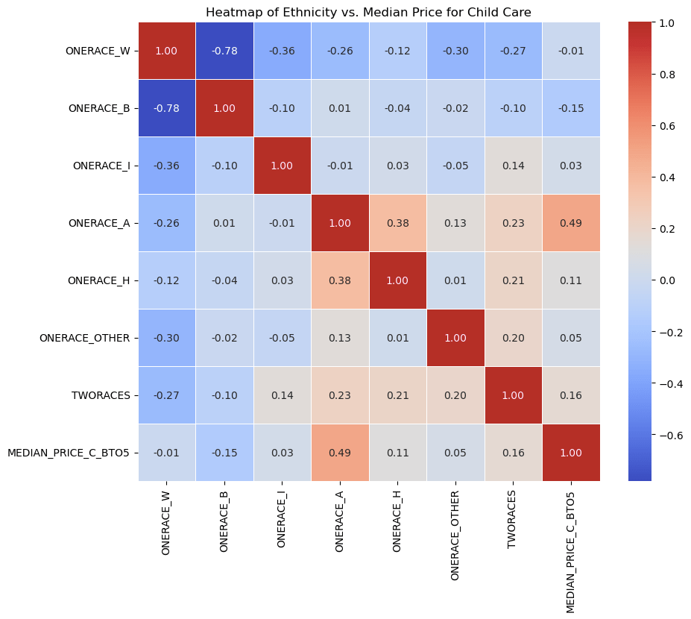](https://mathankumartk.wordpress.com/wp-content/uploads/2025/10/image-7.png)

**The Economic Squeeze: The Impact of Poverty on Child Care Affordability**

Childcare data highlights a significant relationship between poverty rates and the median prices for child care centers. The findings reveal a striking trend: as poverty rates increase, the median price for child care tends to decrease. This negative correlation suggests that areas grappling with higher poverty levels often offer lower child care costs.

This phenomenon raises important questions about the economic challenges faced by families in these regions. Lower child care prices may indicate a struggle to provide quality care in communities where financial resources are limited.

The analysis illustrates a sharp decline in child care prices at lower poverty rates, which then stabilizes as poverty rates rise.

[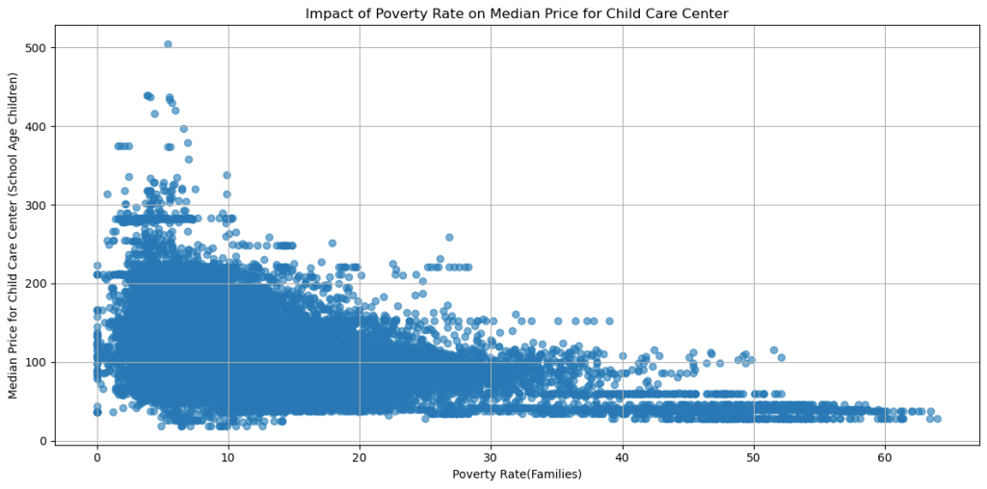](https://mathankumartk.wordpress.com/wp-content/uploads/2025/10/image-6.png)

This information not only sheds light on the financial landscape of child care but also highlights the need for targeted support and solutions in areas most affected by poverty. Understanding these dynamics is crucial for policymakers aiming to improve child care accessibility and affordability for families in need.

**Unequal Burden: Exploring Economic and Racial Gaps in Child Care Costs**

The study reveals significant disparities in median child care prices across various demographics. The data highlights the correlation between economic status and the cost of child care, showing that families from lower-income backgrounds face greater financial burdens. Additionally, racial factors play a crucial role, with certain groups experiencing higher median prices compared to others.

The findings underscore the urgent need for policy interventions aimed at making child care more accessible and affordable for all families, regardless of economic or racial backgrounds. As the debate on child care reforms continues, understanding these complex dynamics is essential for fostering equitable solutions in our communities.

[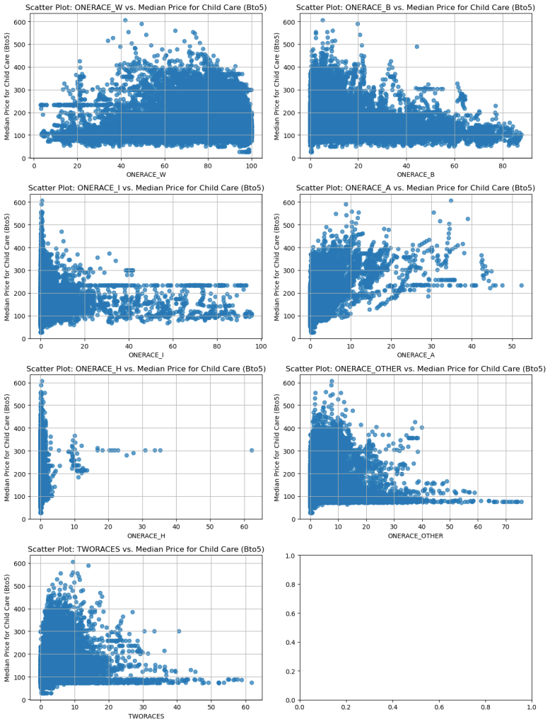](https://mathankumartk.wordpress.com/wp-content/uploads/2025/10/image-5.png)

**Impact of Women's Workforce Engagement**:**State-by-State Analysis**

[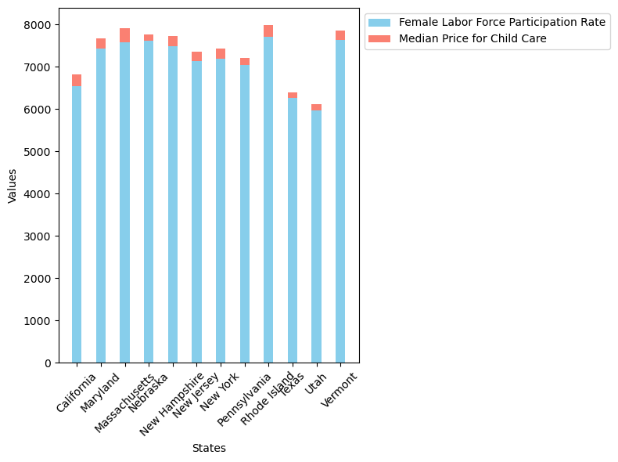](https://mathankumartk.wordpress.com/wp-content/uploads/2025/10/image-4.png)

The Analysis reveals significant variations among states, suggesting that child care affordability plays a crucial role in influencing women's ability to fully participate in the labor market.

In states where child care costs are higher, there may be a corresponding impact on the labor force participation rate, potentially limiting opportunities for many women. This relationship underscores the importance of accessible and affordable child care as a vital support system for working mothers. Policymakers and advocates should pay close attention to these trends to address the barriers faced by families and to develop solutions that promote both economic participation and family well-being.

**Child Care Expense Trends in Households with Single Mothers**

Initial study of child care trends among households led by single mothers has revealed intriguing patterns. Initially, the study indicated a weak positive relationship, suggesting that the number of single-mother households does not significantly influence child care expenses. This implies that other factors may be driving these costs.

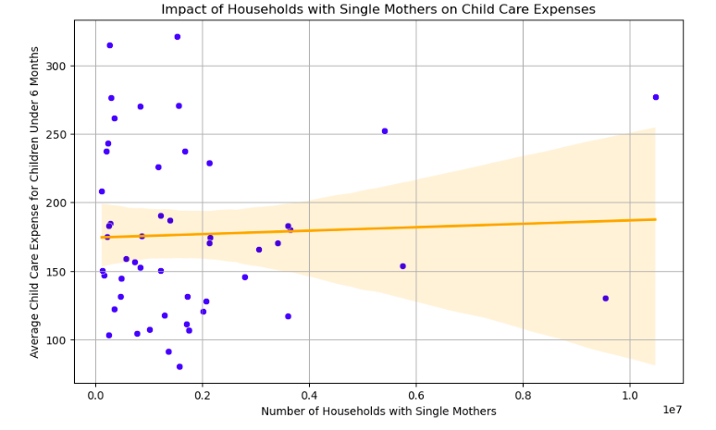

When the analysis was refined to focus specifically on the **top 10 states** with the highest populations of single mothers, the findings shifted dramatically. The correlation strengthened to a moderate positive relationship, indicating that households led by single mothers do have a more substantial impact on child care expenses in these regions.

This transition highlights the importance of considering geographic and demographic factors when examining the link between single mother households and child care costs. It suggests that states with higher concentrations of single mothers face unique challenges that affect child care expenses.

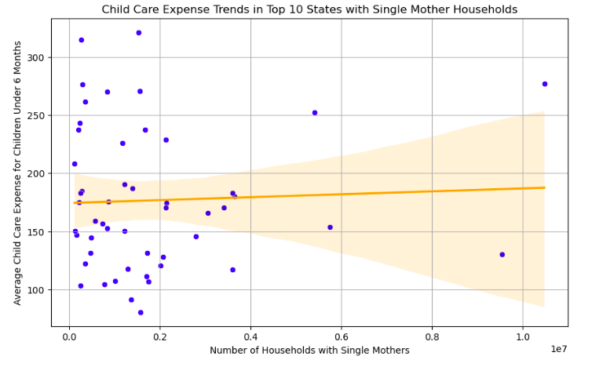

The implications of these findings are critical for policymakers. They underscore the need to understand the regional context when developing support systems for single mothers. States with significant numbers of single-mother households may require targeted financial assistance and resources to help manage escalating child care costs.

While a broad analysis showed only a weak relationship between single mother households and child care expenses, a closer examination reveals a clearer trend in areas with high populations of single mothers. This highlights the necessity for tailored support initiatives aimed at alleviating the financial pressures faced by single-parent families.

**Child Care Expense Trends for Traditional Child Care vs Family Child Care**

Research explores an alternative option for families with infants, revealing a notable upward trend in child care expenses over the study period. The data suggests that the rate of increase in expenses for children under 6 months surpasses that of family child care costs, indicating a significant rise in formal child care settings.

These trends may be reflective of broader economic factors, including inflation and evolving demand for child care services. The findings have implications for policymakers and program developers aimed at supporting families.

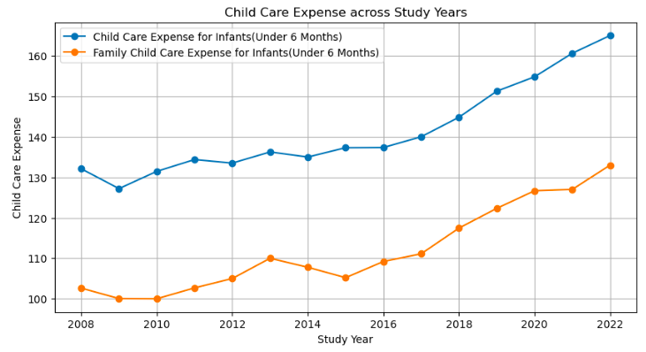

Overall, the analysis highlights an escalating financial burden associated with child care expenses, particularly in formal care environments, emphasizing the need for targeted interventions to alleviate this growing challenge for families.

**Policy Power: How Government Action Can Bridge the Affordability Gap**

Government actions are crucial in bridging the affordability gap. Policymakers at all levels should prioritize child care reform by implementing equitable funding models, enhancing subsidies for low-income families, and ensuring robust support for child care providers. By taking decisive action, governments can create a framework that not only alleviates the financial burdens faced by families but also invests in the future of our society. Together, we can work towards a system that values and supports the diverse needs of families, ensuring that every child has access to quality care and every parent has the opportunity to thrive in the workforce.

**Cultural Shifts: Building a Society That Prioritizes Affordable Childcare**

As we navigate the complexities of child care affordability, it is important to nurture cultural shifts that prioritize accessible and affordable child care for all families. Communities must come together to advocate for systemic changes that recognize child care as a fundamental necessity, rather than a luxury. This cultural shift can be achieved through grassroots movements, community organizing, and raising awareness about the vital role affordable child care plays in promoting family well-being and economic stability.

# Design Decisions

1. Affordability Index is created to measure the influence of various factors on Child Care Affordability.
   1. **Affordability Score = Median Price of Child Care Cost / Median Household Income**
2. On the Map Chart, Affordability by Median Income across state, Alaska state has been omitted for aesthetic purpose, focusing on contingent U.S. states
3. Median Cost of Child Care of various age groups are used for each analysis to demonstrate the variability of cost factor against influencing parameters such as social and economic factors.

# Ethical Consideration

1. I will ensure that there is no inherent bias in the data collection process, such as underrepresentation of certain regions or types of providers.
2. There are NO PII (Personally Identifiable Information) available in the database eliminating the need for anonymization.
3. I did not make any changes to the dataset expect for omitting the data for Indiana and New Mexico States which did not have Median Price for Child Care information.
4. All the transformation done to the dataset (such as Standardizing Feature Names, Handling Missing Values, etc.,) are technical in nature, performed to ease the process of Data Analysis and did not create/introduce any risk.
5. Data is acquired from trusted source made available by Department of Labor and it is not used for commercial purpose.

# Lessons Learned

1. Next time, I would choose a more specific research topic instead of a broad one, focusing on a particular aspect within that topic to allow for a more in-depth analysis and clearer insights.
2. I have thoroughly enjoyed exploring various factors across Social, Economic backgrounds and analyze them to understand how they influence the cost of child care.